Children of three ages are asked to indicate their preference for three photographs of adults.
Do the data suggest that there is a significant relationship between age and photograph
preference? What is wrong with this study?
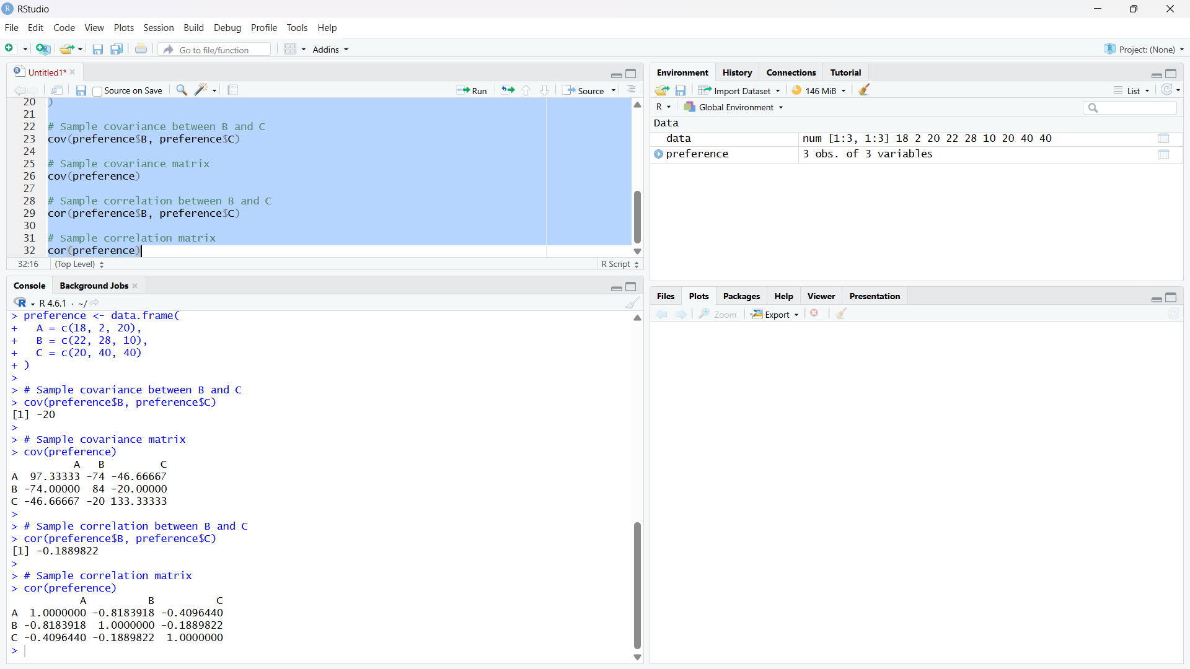
2. Assume the Tennis coach wants to determine if any of his team players are scoring
outliers. To visualize the distribution of points scored by his players, then how can he
decide to develop the box plot?
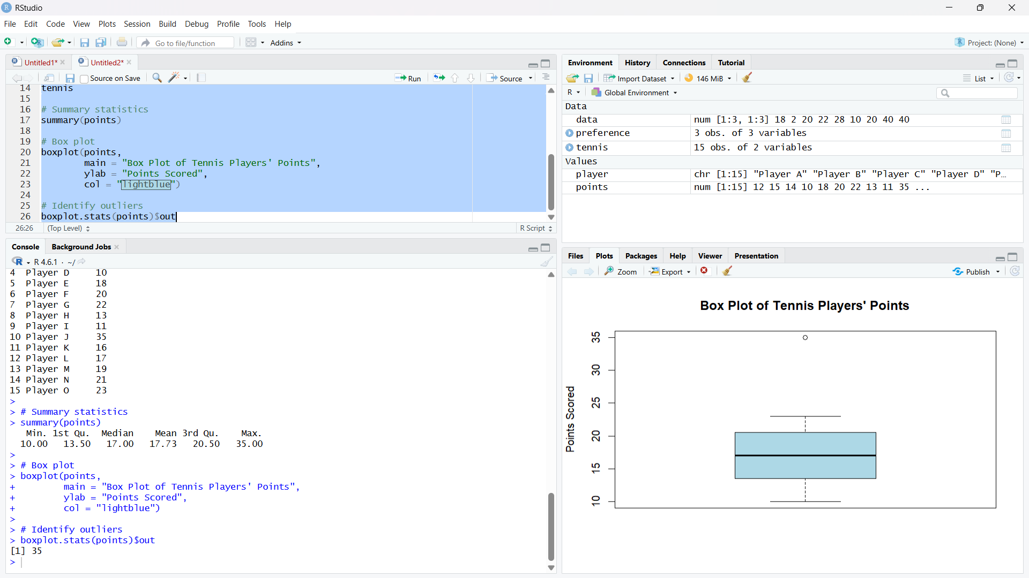

3. A bank wants to decide whether to approve a loan based on customer attributes like:
• Age
• Income
• Employment Status
• Credit Score
Using historical data, build a Decision Tree classifier to predict Loan Approval (Yes/No).
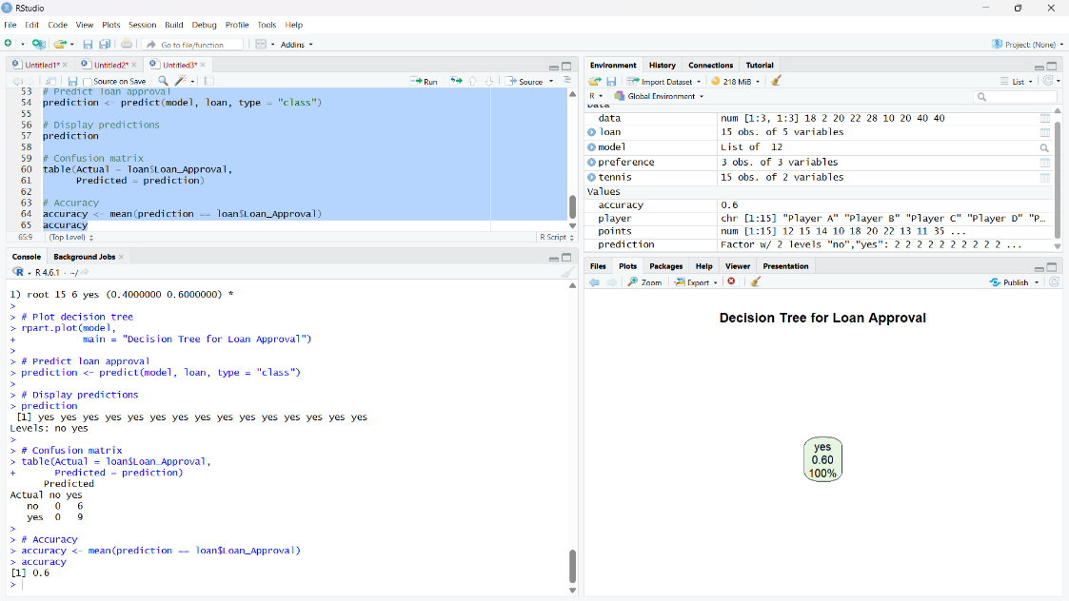
4. Two Maths teachers are comparing how their Year 9 classes performed in the end of year
exams. Their results are as follows:
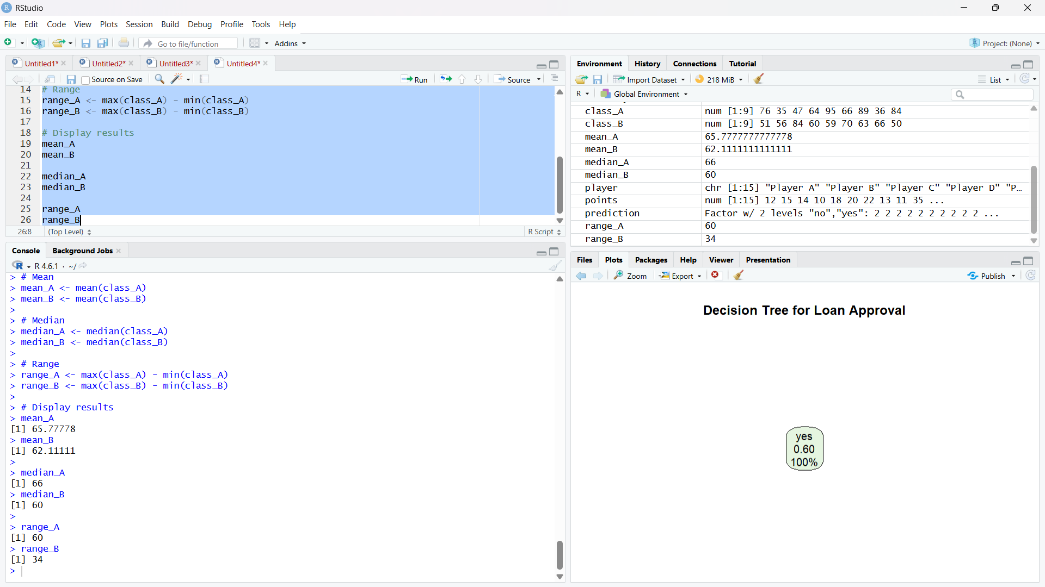

5. Suppose that a hospital tested the age and body fat data for 18 randomly selected adults
with the following results: 